PRACTICAL QUESTIONS FOR DATA VISUALISATION AND ANALYTICS (CIA1C11)
Practical 3 – Exploratory Data Analysis II (Numeric Data)

Introduction: Given a set of raw data, what is the process that one might go through to make sense of the data? Exploratory Data Analysis is about getting to know the data, discovering the problem areas and assessing what needs to be done to improve the data quality. Generally, these are the things that a data analyst will have to go through:
- Data Profiling – to get an overview structure of the data and assess the data quality
- Data Discovery – to use statistics charts to get a sense of the distribution / correlation

Practical 2-4 will introduce students to the application of such Exploratory Data Analysis.

Objective: Assuming preliminary EDA has been done (using metadata, statistics node, crosstab as seen in Practical 2), the aim of Practical 3 is to delve further into EDA techniques for Numeric (Quantitative) data using histograms, box plots and scatter plots/matrix.

Question 1 : To explore numeric data using histograms (interactive histogram node)
Question 2 : To explore numeric data using box plots (box plot, conditional box plot node)
Question 3 : To explore numeric data using scatter plots (linear correlation, color manager, scatter plot nodes)

Dataset: In this practical, we will make use of nutrition information for Starbucks menu items. For more details, you can visit this link (https://www.kaggle.com/starbucks/starbucks-menu)

Ready? Let’s get started!

Question 1 (Plotting Quantitative Data – Histogram)
The purpose of this question is to use histogram to detect the following:
- What is the data distribution for each column of data?
- Are there any anomalies/outliers?

In the process of exploring the data, we may be able to discover things such as:

- What is the distribution of menu items by their protein/calorie content?
- Are there many drinks with high calories content? How is the sugar content for these drinks?
- Do healthier drinks (lower calories) have higher dietary fibre?

- Create a new Workflow in the DAVA Workflow Group. Call this Workflow P03_Q1
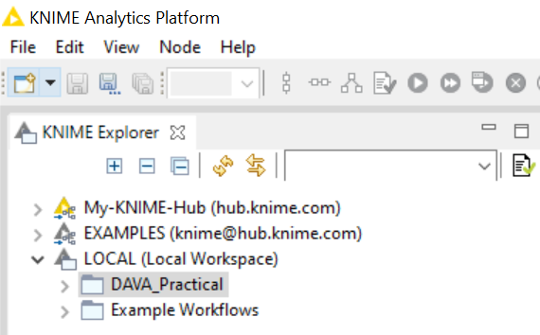
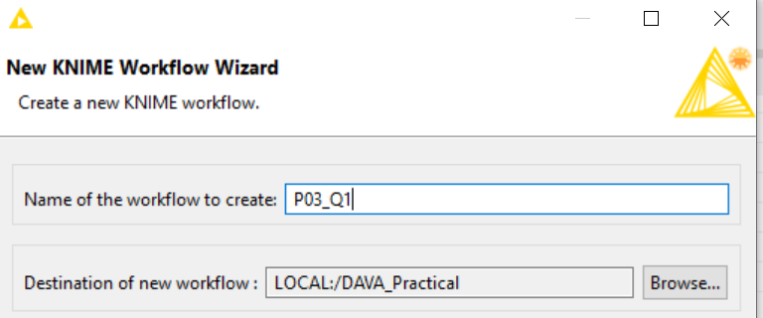
- File Reader
Using a File Reader node, read in the Starbucks Menu starbucks_drinkMenu_expanded.csv
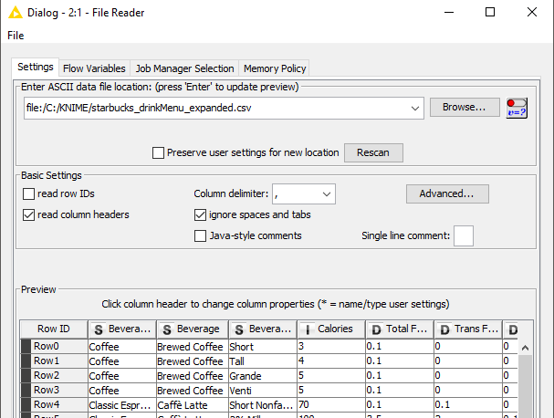
Be sure the set the delimiter as comma (,) and check the checkbox to read column headers.

- Our file contained some special characters, for example, the symbol for registered trademark (®), as well as the accent in the letter è.

In order for us to read it in correctly. Click on the Advanced button, navigate to the Character decoding tab and select UTF-8 as the character set.
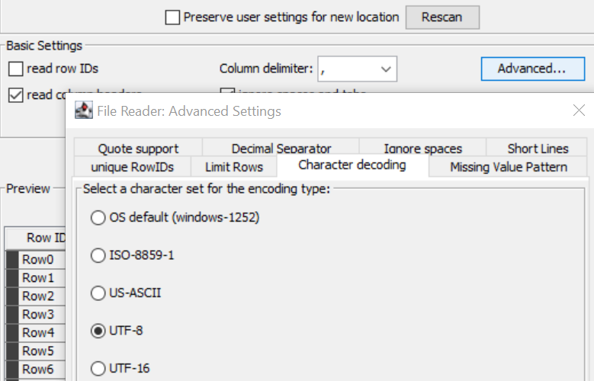

- Execute the File Reader node. This dataset contains 242 records of Starbucks’ food and drink menu items with their nutritional information.

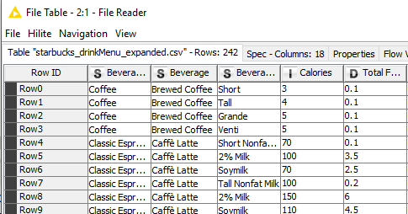

- Interactive Histogram
Add a Interactive Histogram node downstream from the File Reader node.

Configure the Interactive Histogram node as follows:
- Binning column: Protein
- Aggregation columns: None
- Check the checkbox for Display all rows
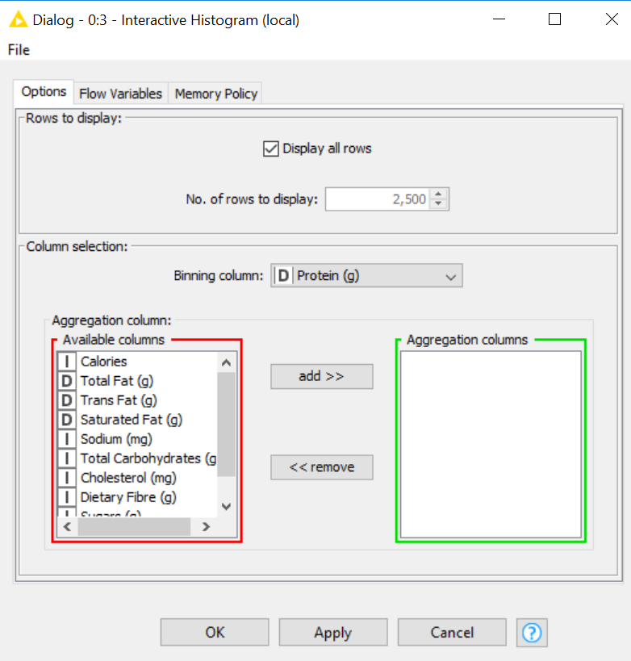

Notice that we did not select any Aggregate columns for now.

Right click on the Interactive Histogram node and select Execute and Open View.
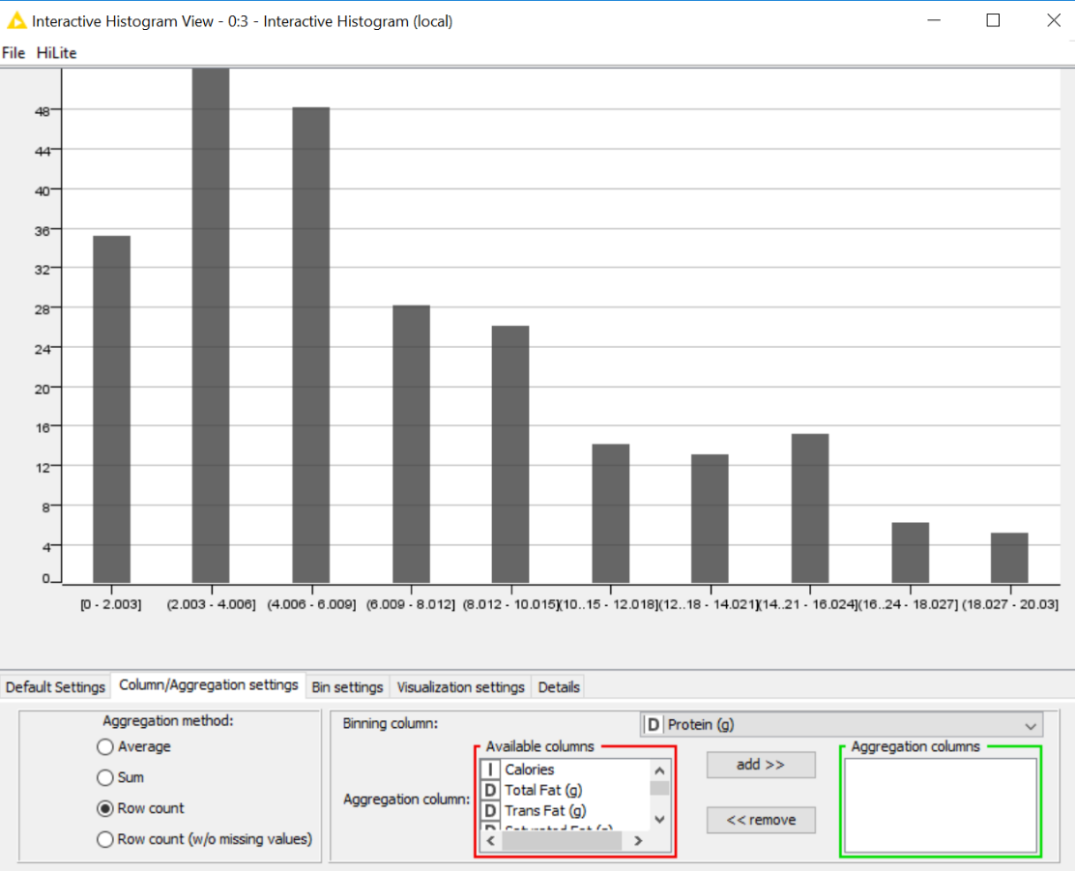

Navigate to the Column/Aggregation settings tab. Notice that the Aggregation method is set to default Row count. This is because we did not select an aggregation column earlier under configuring the Interactive Histogram node.

 | Question:  - What is the shape of the distribution for protein? What is the cause?
Answer:

Notice also that we can make changes to the Aggregation methods, Binning Column field and the Aggregation column. (We will do that later).

- Navigate to the Column/Aggregation settings tab. Change the Binning column to Calories.
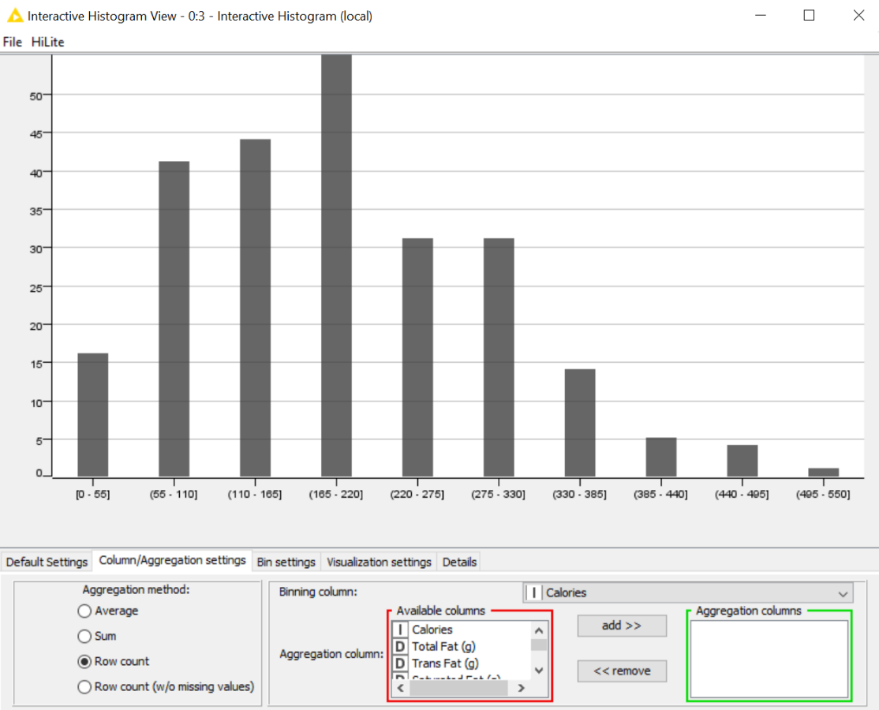

Navigate to the Visualization settings tab and check the radio buttons for Labels group. Select Selected elements and Horizontal view. Click on any bar to select it, then click again to de-select.

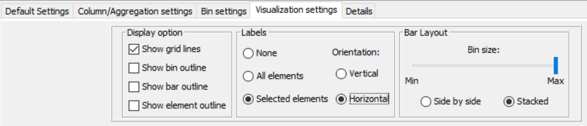

 | Question:  - What is the shape of the distribution? Which calorie range has the highest frequency? Are there many drinks with high calories content?
Answer:

- Navigate to the Column/Aggregation settings tab and make the following changes:
- Binning column: Calories
- Aggregation columns: Sugars
- Aggregation method: Average
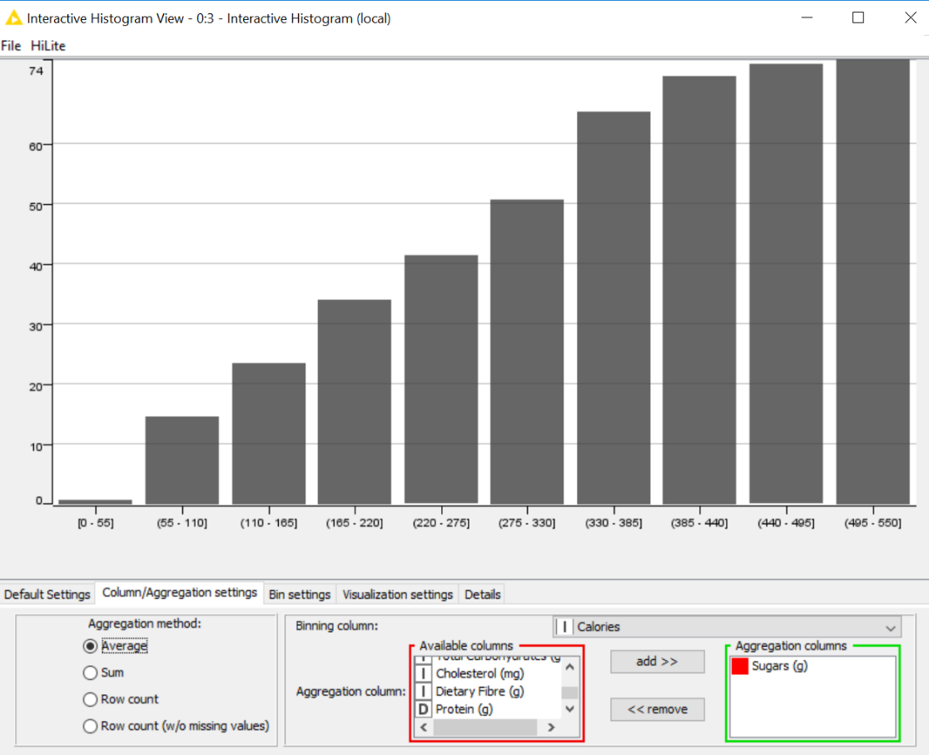

 | Discussion: Do you notice anything different in the output?  What is the purpose of an aggregation column in a histogram?
Answer:

The vertical axis now shows the average level of Sugar for each category of calorie content.

In some situations, you might not want to height of the ‘bar’ in your histogram to represent the raw count of the number of items falling into each bin. In that case, you will need to specify the aggregation column as well as the aggregation method.

 | Question:  - How is the sugar content for unhealthier drinks (higher calories)?
Answer:

- Navigate to the Bin settings tab, change the Number of bins to 5.
Notice how the histogram changes? This is a useful feature for tweaking the ranges of each bin.

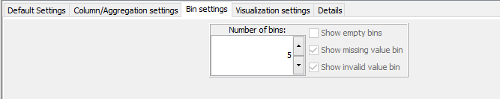
Tip: You can use the Fit to size button in the Default Settings tab to refit the histogram after making any changes.

Let’s make more changes to the Interactive Histogram.
Navigate to the Column/Aggregation settings tab and make the following changes:
- Binning column: Calories
- Aggregation columns: Dietary Fibre
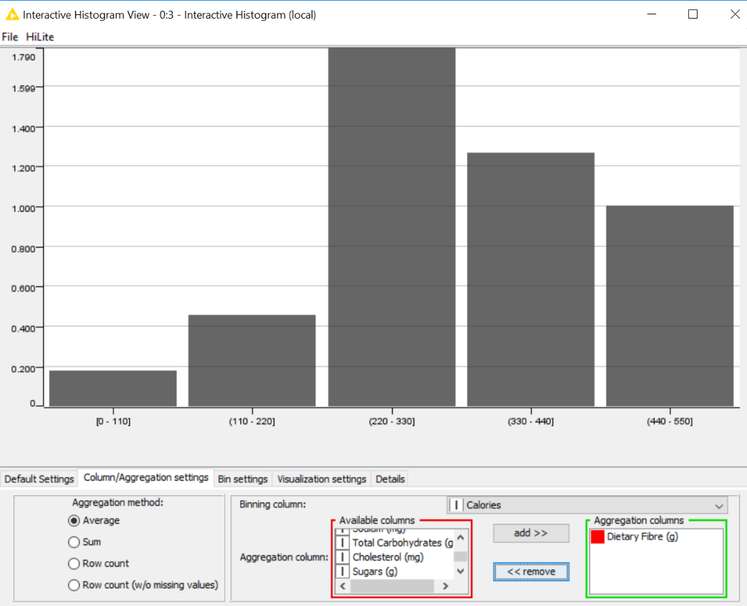
- Aggregation method: Average

 | Question:  - Do healthier drinks (lower calories) have higher dietary fibre?
Answer:

- Save your Workflow.
Question 2 (Plotting Quantitative Data – Box-Plot)
The purpose of this question is to use box plot to detect the following:
- What is the spread of the distribution for each column of data?
- How does the spread of the distribution for one category compare with another?
- Are there any anomalies/outliers?

In the process of exploring the data, we may be able to discover things such as:

- Are there any menu items with unusually high / unusually low sodium and/or sugars content?
- Which category of drinks have the highest Total Fat content?
We will continue this question in the P03_Q1 workflow.
- Box Plot
Connect a Box Plot node (under Local (Swing), not Javascript) to the File Reader node. No configuration is required. Select Execute and Open View.

Listed below some information about Box Plots.
- Box Plots displays minimum, lower quartile (Q1), median (Q2), upper quartile (Q3), and maximum of numeric fields.
- The distance between Q1 and Q3 is called the interquartile range (IQR).
- The box goes from the lower quartile (Q1) to the upper quartile (Q3). The median is drawn as a horizontal bar inside the box.
- Above and below the box are the whiskers. They are drawn at the minimum and the maximum value as horizontal bars. The whiskers never exceed 1.5 * IQR.
- If there are some data points which exceed either Q1 - (1.5 * IQR) or Q3 + (1.5 * IQR) than the whiskers are drawn at exactly 1.5 * IQR mark and the data points which exceeded the 1.5 * IQR marks are drawn separately as outliers.
- Outliers that are between 1.5 and 3 times the IQR are called mild outliers, they are represented by a dot (•).
- Outliers that are beyond 3 * IQR are referred to as extreme outliers, they are represented by crosses (+).

- By default, the Box Plot node will generate plots for all numeric fields, you can then select / deselect the fields in the output. Navigate to the Column Selection tab, remove all fields except for the Trans Fat field.
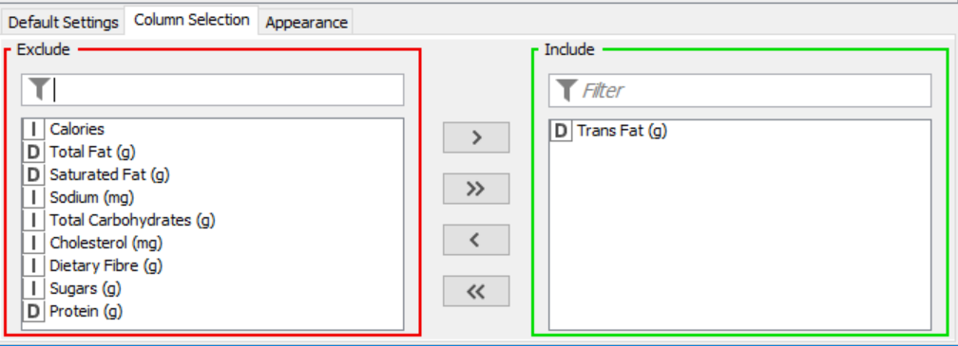

- We can see that for Trans Fat:
- Q1 = 0.1
- Q2 (median) = 0.5
- Q3 = 2.0
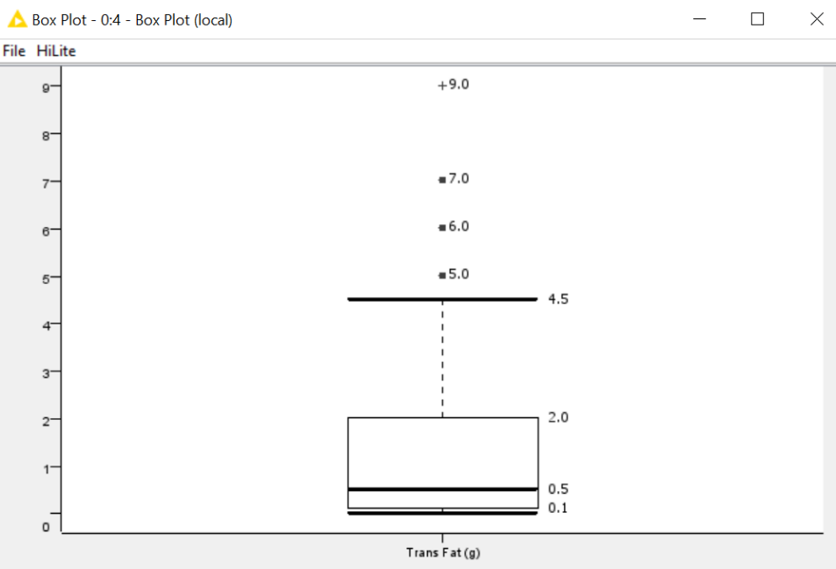

 | Question:  - Are there any menu items with unusually high / unusually low trans-fat content?
Answer:

Close the View window.

Right click on the Box Plot node and select Robust Statistics (they are so-called because these statistics measures are not easily affected by outliers).
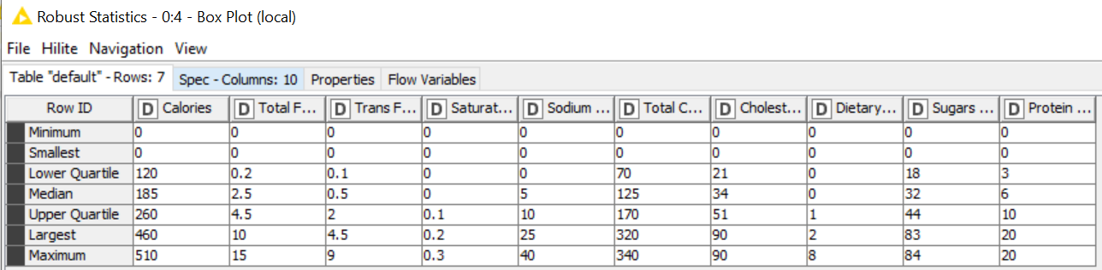
You can read off the robust statistics from the resulting table.

 | Discussion: What is the difference between min and smallest?  What is the difference between max and largest?
Answer:

Min/max refers to the true/actual min/max value of data.
Smallest/largest refers to the value of the lower/upper whiskers.

- Conditional Box Plot
It may be useful to have separate box plots if you have nominal fields. To do that, we can make use of the Conditional Box Plot node.

Add a Conditional Box Plot node (under Local (Swing), not Javascript) downstream from the File Reader Node.

Configure the Conditional Box Plot as follow:
- Nominal column: Beverage_category (x-axis)
- Numeric column: Total Fat (y-axis)
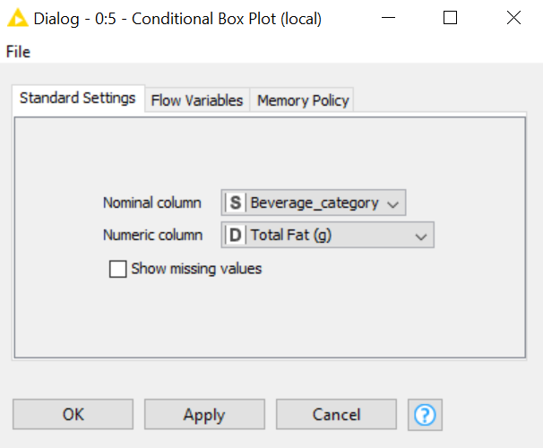

Right-click to Execute and Open Views.
The conditional box plot produces box plots of the same field (Total Fat), separated by the selected nominal field (Beverage Category).

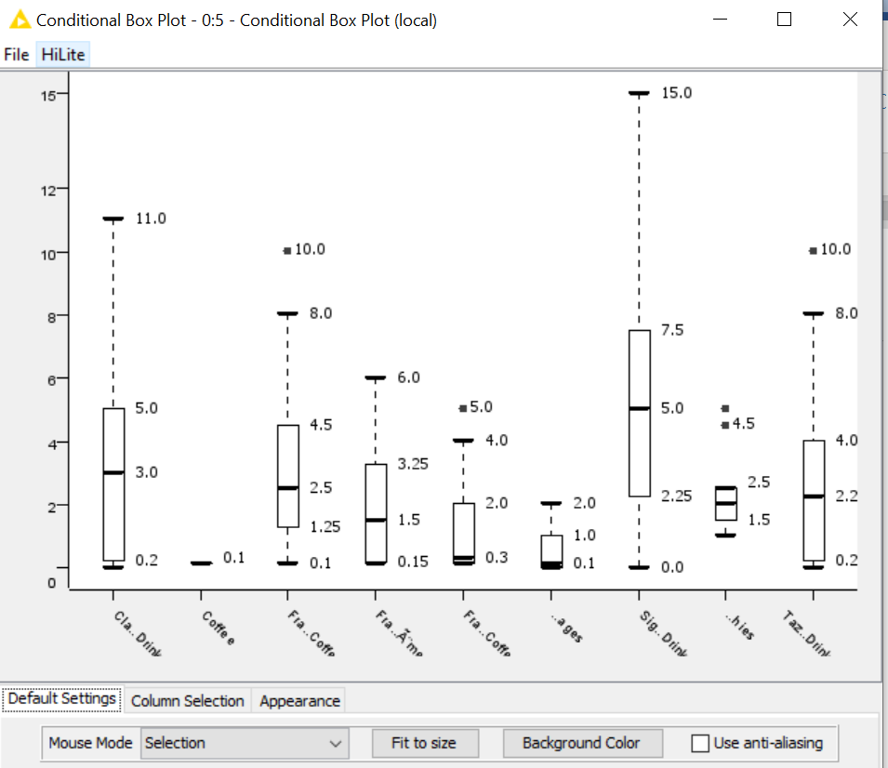

 | Question:  - Which category of drinks have the highest Total Fat content?  (Note : You can hover over the Axis Titles to see the full name.)
Answer:

- Save your Workflow.

 | Reflection:  What type of data can be on the x-axis of a histogram?  What type of data can be on the x-axis of a conditional box plot?  What is the difference between box plot and conditional box plot?
Answer:

Question 3 (Linear Correlation node)
The purpose of this question is to explore the correlation/distribution between two numeric variables. The question to consider is:
- Are there any two variables that are highly correlated?

We will continue this question in the P03_Q1 workflow.
- Linear Correlation
The next node we are going to use is the Linear Correlation node. You can either search for it, or expand the Analytics nodes group and Statistics nodes sub-group.
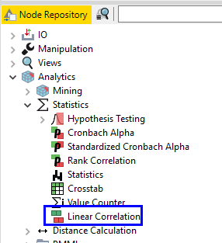

Add this node to your workflow, connect it downstream from the File Reader node.
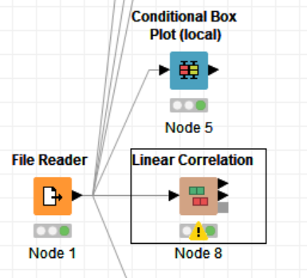

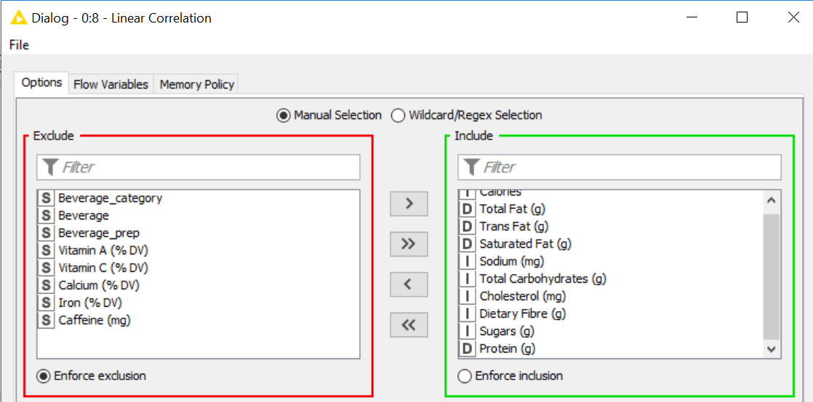
Configure the node to select only the numeric fields.

Close the configuration window.

- Right-click on the Linear Correlation node and select Execute and Open Views.
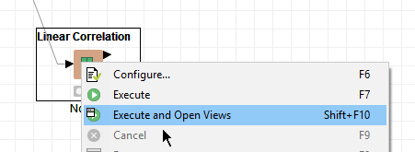
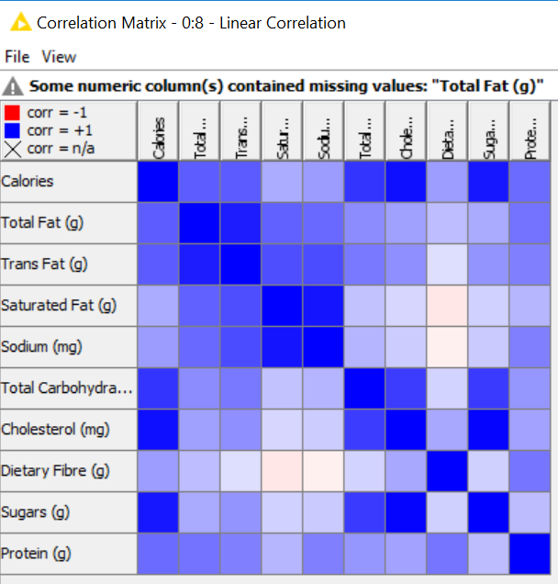
The result of the node is a correlation matrix showing the correlation between the fields. You can select View > Cell Size to enlarge the cell in the correlation matrix (suggest you change to 30).

The diagonal of the matrix should not be interpreted since a field would always have strong, positive correlation with itself. Instead we should pay attention to cells with dark colours that are not on the diagonal.
In this instance, we can see that Trans Fat has a moderately strong and positive correlation with Total Fat (Blue) with correlation coefficient r = 0.891. You can mouse-over any cell to view the Pearson correlation coefficient.

 | Question:  - Which variables have the highest correlation?  Which variables have the lowest correlation?
Answer:

The field is most blue

- Save your workflow.

 | Reflection:  What do you look out for in a correlation matrix?
Answer:

Question 4 (Plotting Quantitative Data – Scatter Plot)
The purpose of this question is to use scatter plot to detect the following:
- Whether there is any correlation between two variables?
- How does the spread of the distribution for one category compare with another?
- Are there any anomalies/outliers?

In the process of exploring the data, we may be able to discover things such as:

- Which are the beverages with high sugar and high cholesterol content
- Do they mostly belong to one or two drink categories?

- Color Manager
Search for the Color Manager node. Connect it to the File Reader node.

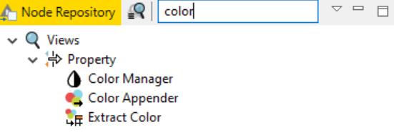

Access the configuration of the Color Manager node. Ensure that the Beverage_category field is selected. You can use the colour picker to change assigned colours for each of the values in the Beverage_category field, at the moment, the colours are fine for our purpose, so we will leave it.
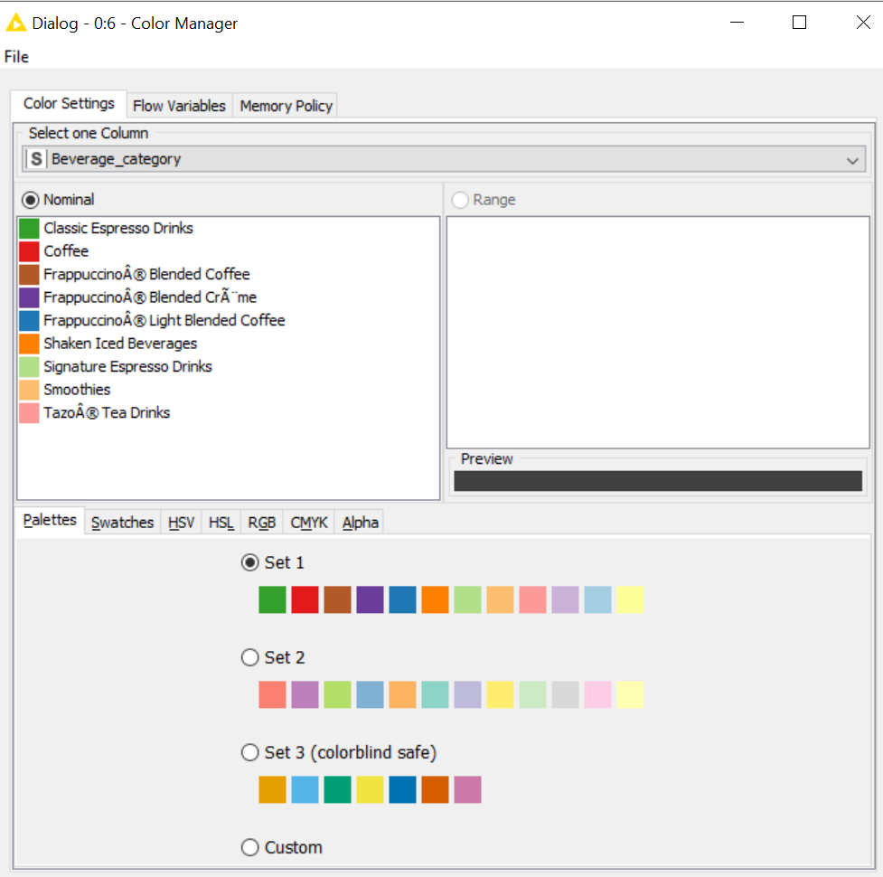

- Scatter Plot
Search for scatter plot by typing scatter in the search bar of the Node Repository. You may see several implementations of scatter plots; the node we are looking for is the Scatter Plot node, found in the Views group (under Local(Swing), not Javascript).
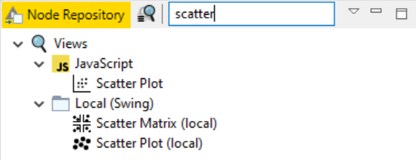

- Connect the Scatter Plot node to the Color Manager node and open the configuration view, by default, all fields are included in the plot. The number of rows to display is 2500, since our dataset only consists of 300+ rows, this is ok, but you might want to modify this value for larger datasets.
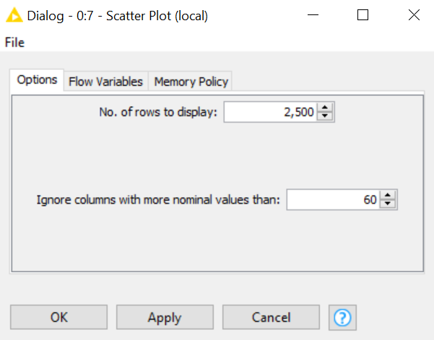

Close the configuration view, select Execute and Open View.

- In the resulting view, navigate to the Column Selection tab.
Notice that the default setting is Beverage Category as x-axis and Beverage as y-axis.

Select Sugars as the x-axis values and Cholesterol as the y-axis values.
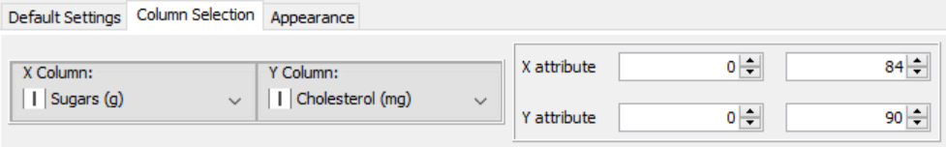

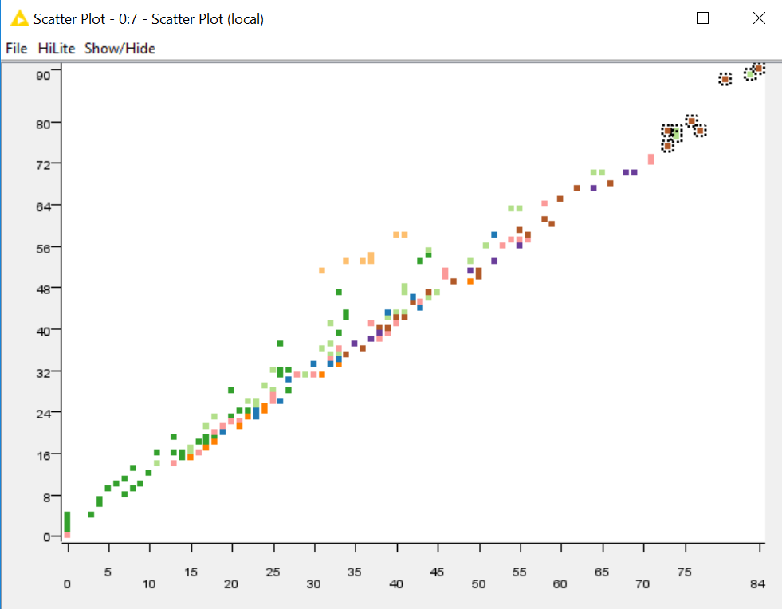
- From the scatter plot, we can see that some of the menu items have high sugar and high cholesterol content. These are data points in the upper right quadrant. We want to take a closer look at these items. You can do this by left clicking on the chart and dragging your mouse, this would create a selection box. Don’t worry if your selection is slightly different from the one shown in the screenshot below. Just select some data points at the top right quadrant.

Once you have made the selection, select HiLite > HiLite selected.
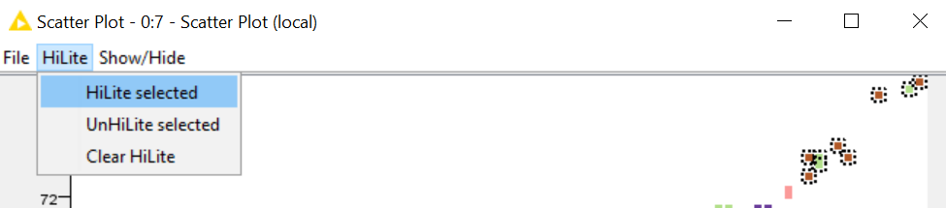

- Close the scatter plot view. Return the File Reader node and select File Table.

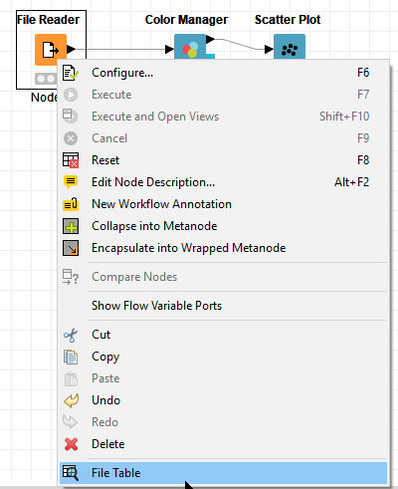

You would see that some rows in the table would be highlighted. (Once again, don’t worry if your highlighted row is different from what is shown in the screenshot below).

You can re-position the columns you are interested in to be next to one another. Simply drag and drop the column headers to the desired position.
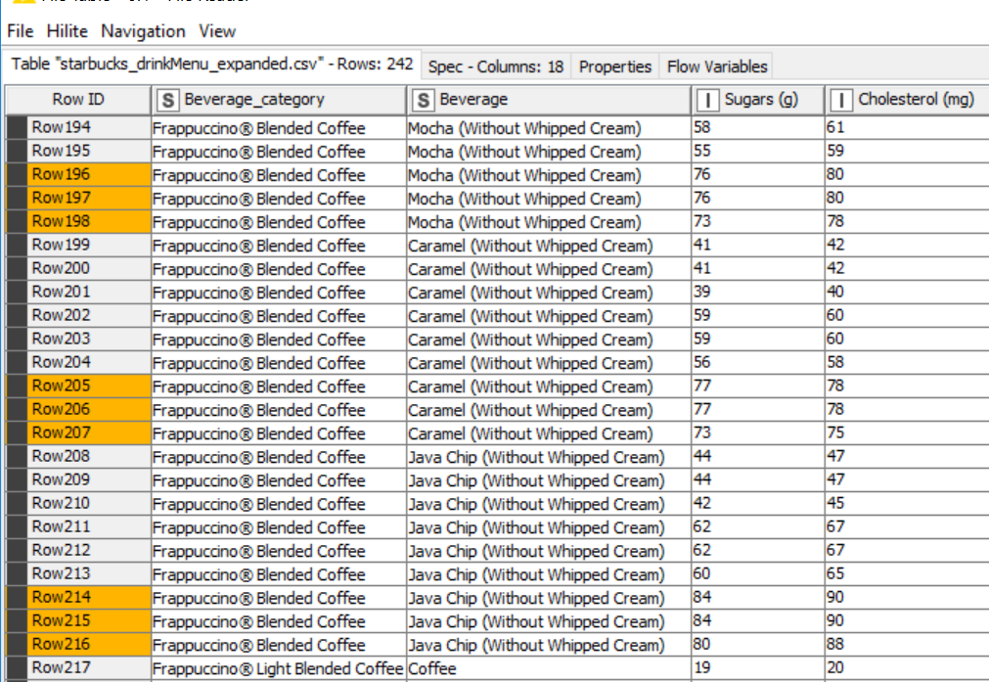

HiLite is a useful function in KNIME, it is not only restricted to scatter plots, you can find HiLite option in most nodes. During exploratory data analysis, HiLite can be use if you suspect that there are data points which are out of the ordinary, these can be highlighted and corrected or discarded.

 | Question:  - Which are the beverages with high sugar and high cholesterol content?  Do they mostly belong to one or two drink categories?
Answer:

- Save your workflow.

 | Reflection:  What is the scatter plot used for?
Answer:

Question 4 (Practice Question – Will not be covered in class)
- Create a new workflow and read the glass dataset (glassReadings.csv) into KNIME.

- Create box-plots for the Refractive_Index field, separated by Glass_Type.
Which Glass_Type contains the most extreme outliers for Refractive_Index reading?

- Create a histogram showing Average Calcium content of glass readings, binning by Glass_Type.
Which Glass_Type has the highest average Calcium content?

– End of Practical 3 –

 | Summary:
In this practical, we explored the use of simple visualizations to explore numeric data. Charts such as histogram and box plots provide visual summaries on the distribution of numeric data and may be able to point out some things that summary statistics might not be able to.

Correlation analysis allows us to explore interactions between two numeric fields while Scatter plots provides us with a means to visualize distribution across two numeric fields. When combined with colour, a third dimension can be presented.
In this practical we made use of the following new nodes (not covered in previous practical) in KNIME.
Node | Purpose | Remarks
Histogram (interactive) | Separate data into bins and present the raw count of data points in each bin. It allows on-the-fly changes to number of bins, binning column, aggregation column(s) and aggregation method. | If aggregation column is selected, will display the aggregation (average, sum, count) of the aggregation column for each bin.  If you have more than 2500 data points, it is important that you check the checkbox to display all data
Box Plot | Produces a visual representation of where 50% of your data points lies within. Shows you if there are any mild or extreme outliers. | When you have fields with different ranges, it can be difficult to read the boxplots. You can choose to only display fields that you are interested in, or look at the robust statistics.
Conditional Box Plot | Similar to box plot, except that it is mainly used for only 1 selected numeric field. Will produce 1 box-plot for each category in the selected categorical field. | Robust statistics is also available for conditional box plot.
Linear Correlation | Computes the linear correlation coefficient between numeric fields | You can right-click on the node and select Correlation Measures to view the various coefficient values.
Color Manager | Used for assigning colours to different values in a categorical field. | Can change colour if you want.
Scatter Plot | Unlike box-plot and histogram, scatter plot shows you where one characteristic for a data point is, in relation to another characteristic. It shows you 2 pieces of information about the same data point in a single plot. | Add colour to the points in the scatter plot and you get to see 3 pieces of information in a single plot.

